1ST WORKSHEET
CORRECTION
NAME: |  | GRADE:
AIM: | Speaking: Presentar información en forma oral, usando recursos multimodales que refuercen el mensaje en forma creativa acerca de temas variados (como experiencias personales, temas de otras asignaturas, otras culturas, problemas globales y textos leídos o escuchados). | DATE:
CONTENTS: | Describe people /Adjectives

INSTRUCTION: Before you start working with this worksheet, please go and look the content in the power point presentation.

1.- Create your own avatar: Look at the template of the person, use the vocabulary learnt to draw the part of the avatar that you like and write about the appearance, personality, emotions and preferences that your avatar has. Present your avatar to the class.
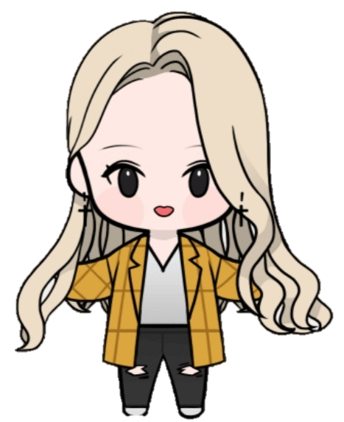

1.1.- Write: describe YOURSELF, appearance, personality, emotions and preferences.

I’m medium height and slim. I have got long, wavy and blond hair.
I also have fair skin and green eyes.
I have a tattoo on mi left arm and a piercing in my left ear.
I’m clever, beautiful, dreamer, strong, brave, imaginative, creative, loyal, trustful, impulsive and a little bit grumpy sometimes.
I love to take picture with my camera, I like draw and sing, I hate injustice and I don’t like maths.

Remember the use of connectors

2.- Complete the crossword reading the clues, use the vocabulary learnt in class.
